**PROJECT TITLE**

***DIGITAL SYSTEM DESIGN LAB***

***MINI PROJECT***

**Electronics and Communication Engineering**

*Submitted by*

**Student Name**: Shaik Faizan, Nandana Jayan,

Avinash Kumar, Divyashree Dey

**Reg. No.: 210907274, 210907001, 210907092, 210907156**

*Under the guidance of*

# SUPERVISOR NAME Designation

**DEPARTMENT OF ELECTRONICS AND COMMUNICATION ENGINEERING** A screenshot of a cell phone

Description generated with very high confidence

MANIPAL-56104, KARNATAKA, INDIA

**NOV/DEC 2022**

**ABSTRACT**

Owing to today’s fast paced world, the stress load has increased and has made it difficult for us to focus on one task. We, are constantly busy and always tired. Accidents due to drivers falling asleep while driving are common and it is imperative that we counter this problem. So, to address this issue, we have come up with a Driver Anti-sleep Device. This system alerts the user if he/she falls asleep at the wheel thereby, avoiding accidents and saving lives. This is very useful for people who frequently travel long distances by car and late night journeys. Mostly needed by drivers such as truck drivers as they travel a long duration of time and can sleep due to tiredness. Office hour people after working for long hours like IT people who generally work late at night. Long distance driving and in that if someone is sleeping beside the driver it can cause distraction.

The working of this project is based on an Infra Red Sensor, This sensor is the heart of this project. IR LED continuously transmit the infra red rays and if any object comes in front of it, IR rays get reflected back and it received by the photo diode due to this change in IR radiation the voltage at the anode get change, the change in anode voltage is depend on the IR radiation received by the photo diode.The sensitivity distance is set to the distance between our eyeball and the device.If our eye is closed there is a change in the distance between the eye and the device which is perceived by the IR sensor and it sends a signal to the buzzer causing it to beep.

When the eye is closed for a few seconds,this is detected by our Anti Sleep device.This is followed by a loud beep causing the user to awake from his brief period of drowsiness and put his attention back to the road. In this project, we aim to create a driver anti sleep device detector, using buzzer which helps to wake up the driver.

Our device strives increase road safety and decrease the number of accidents that take place.Our device aims relieve the burden of the families of these late night commuters by using our device as a precaution against sleepiness during their travels.Loss of life and property can be significantly decreased with the help of our device.

|  |  |  |  |  |  |
| --- | --- | --- | --- | --- | --- |
| **Contents** | | | | |  |
|  | | | | | Page No |
| Abstract | | | |  |  |
|  | | | | |  |
| **Chapter 1** | | | **INTRODUCTION** | |  |
|  | **1.1** | Introduction | | |  |
|  | **1.2** | Motivation | | |  |
|  | **1.3** | Objective of Report | | |  |
|  | | | | |  |
| **Chapter 2** | | | **BACKGROUND THEORY** and/or **LITERATURE REVIEW** | |  |
|  | **2.1** | **ATtiny13A** | | |  |
|  | **2.2** | Use of IR transmitter | | |  |
|  | | | | |  |
| **Chapter 3** | | | **METHODOLOGY** | |  |
|  | **3.1** | Block diagrams, code, circuit | | |  |
|  | **3.2** | Working of IR transmitter | | |  |
|  | | | | |  |
| **Chapter 4** | | | **RESULT ANALYSIS** | |  |
|  | **4.1** | Working of the circuit | | |  |
|  | **4.2** | Use of ardunio in circuit | | |  |
|  | | | | |  |
| **Chapter 5** | | | **CONCLUSION AND FUTURE SCOPE** | |  |
|  | **5.1** | Work Conclusion | | |  |
|  | **5.2** | Future Scope of Work | | |  |
|  | | | | |  |
| **REFERENCES** | | | | |  |
| **ANNEXURES (OPTIONAL)** | | | | |  |
| **PROJECT DETAILS** | | | | |  |

## CHAPTER 1

## INTRODUCTION

* 1. Introduction

This chapter briefly discusses about the main objective behind our device and its context to the present day scenario. Nowadays working around the clock is the norm. People are on the move 24x7 and to keep up with this constant progress they cut back on their rest time. Living in such a state of perpetual tiredness is dangerous not only for ourselves but for our surroundings too. A person driving home for a long day’s work may get drowsy in front of the wheel. His hands are on the steering wheel and his feet on the pedal but he is succumbing to his sleepiness. This is a dangerous situation that can lead to fatalities. Accidents due to drivers falling asleep while driving are common and it is imperative that we counter this problem. So, to address this issue, we have come up with a Driver Anti-sleep Device.

* 1. Motivation

These days many Anti sleep devices can be found on the market. So what makes ours so special? The answers lies in the difference in detection of both the traditional and our version of the device.The traditional approach involves a tilt sensor which works on the concept in which if the tilting angle of the head exceeds a certain degree it issues an alarm.But this has many drawbacks such as that if the driver is bending to pick up something it may cause a false alarm or the driver may even fall asleep without bending his head in which the alarm will never ring.Our updated version works on the principle of an IR sensor.If the users eye is closed for more than a few seconds,it issues a loud beep successfully awakening the driver from his drowsy state.

* 1. Objective

With this device we seek to bring safety and precaution into all of our user’s lives. Driver sleepiness and falling asleep at the wheel are considered to cause a significant proportion of road traffic accidents, particularly during night driving. The main objective of a sleepiness detection device is to warn of unexpected sleepiness and save lives.

CHAPTER 2

BACKGROUND THEORY:

In this chapter we are going to discuss about the title of the project and we will discuss about the background theory of the project in brief.

In this project, the IR Led works as IR transmitter, and the device is mounted according to a certain distance set by the potentiometer under which the model functions. LED continuously transmit the infra red rays and if any object comes in front of it, IR rays get reflected back and it received by the photo diode due to this change in IR radiation the voltage at the anode get change, the change in anode voltage depends on the IR radiation received by the photo diode.

The sensitivity distance is set to the distance between our eyeball and the device by the potentiometer. If our eye is closed there is a change in the distance between the eye and the device which is perceived by the IR sensor and it sends a signal to the buzzer causing it to beep.

Further Arduino comes into use to code the program for the device(minimum time after which the device functions), it has 14 input output pins, out of which 6 can be used as PWM outputs, 6 analog inputs , a reset button, and holes for mounting pin headers. Code is transmitted from the system using a usb.

The ic used in project is **ATtiny13A** which is used to store the code and The **ATtiny13A** is a low-power CMOS 8-bit **microcontroller. ATtiny13A** executing powerful instructions in a single clock cycle

CHAPTER 3:

**METHODOLOGY**

**INTRODUCTION:**

In this chapter we are going to discuss the proposed methodology of our project.

It will include components used, circuits, code used, block diagrams, the basic functioning of all the components.

**Methodology:**

Implementing an automated system that provides high security to driver and the passengers, by designing an anti-sleep spectacles which monitors the no. of seconds the eye closes for, once when the eye closes for 4 seconds(that means the driver is sleepy), the IR sensor emits IR Rays which is received by the photo diode, there is a sensitivity distance set and when the eye closes, due to this closing, the distance changes, and this is perceived by the IR Sensor, which further causes the buzzer indication which alerts the person.

**PROJECT ARCHITECTURE:**

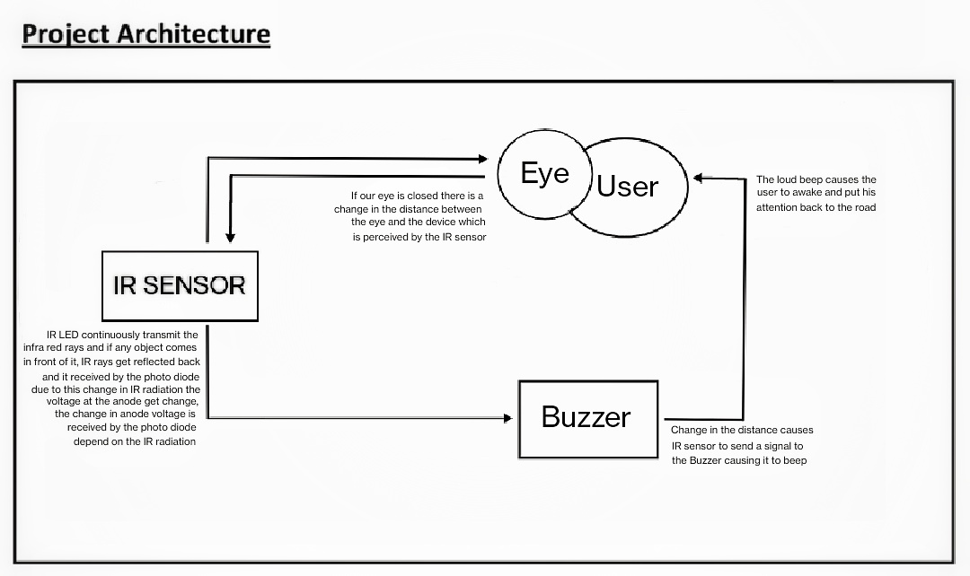

**Code:**

**CIRCUIT DIAGRAM:**

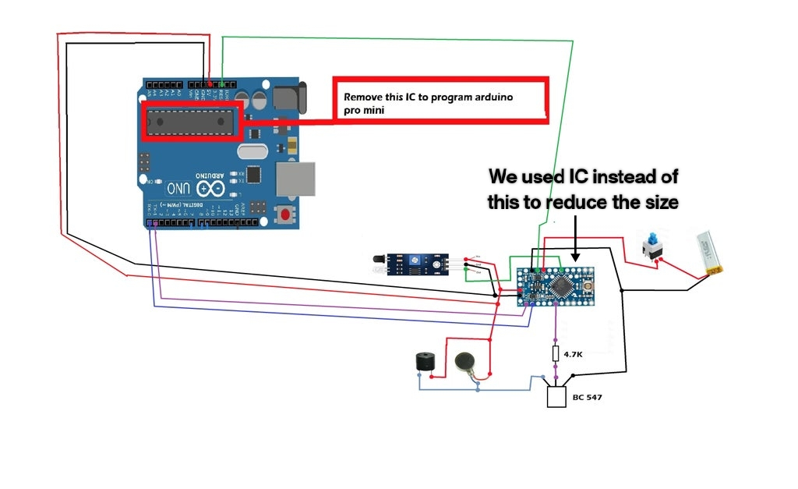

**COMPONENTS USED:**

IC ( **ATtiny13A** )

IR SENSOR

GLASS FRAME

ARDUINO MINI

BUZZER

WIRES

BATTERY

CHAPTER 4

**RESULT ANALYSIS:**

**INTRODUCTION:**

We are going to discuss about the results that we obtained after completing the project.

**Result Analysis:**

The model works based on the eye sensor. Whenever the user closes his eyes for 3 seconds or more, the sensor starts to beep. The Arduino manages the delay for activating the buzzer after sensor input.

The anti-sleep device has the capability to alert the user when he/she is supposed to be attentive, thus avoiding many accidents.

CHAPTER 5:

Conclusion:

We have concluded that:

* It is possible to create a simple yet effective and efficient anti sleep driving device which can have multiple uses irrespective of its name.

Example: it can be used by security guards who have late night duties.

* The device might not be cheap at first but as the law of diminishing marginal utility states as consumption increases the cost decreases.
* This device is portable, i.e. it can be placed in other spots also like sunshield (in front of the user).

Future Scope:

This device with further advancements, can be converted into a product and even can come preinstalled in the upcoming automobiles as a safety feature.

References

* [www.create.arduino.cc](http://www.create.arduino.cc)
* [www.hackster.io](http://www.hackster.io)
* www.instructables.com